Mouse Hover and Hover and Click-ad

Actions action = new Actions(driver);

WebElement mainMenu = driver.findElement(By.linkText("MainMenu"));

action.moveToElement(mainMenu).moveToElement(driver.findElement(By.xpath("submenuxpath"))).click().build().perform();

Dropdown,-se

selectByValue

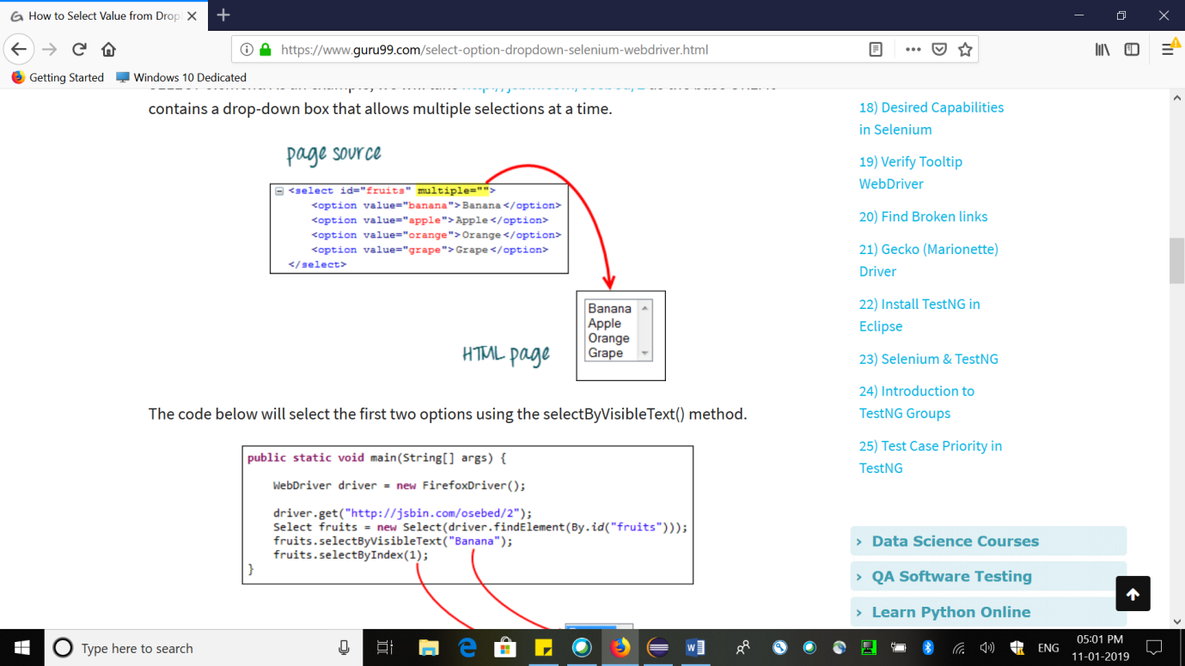

Radio Button/checkbox,

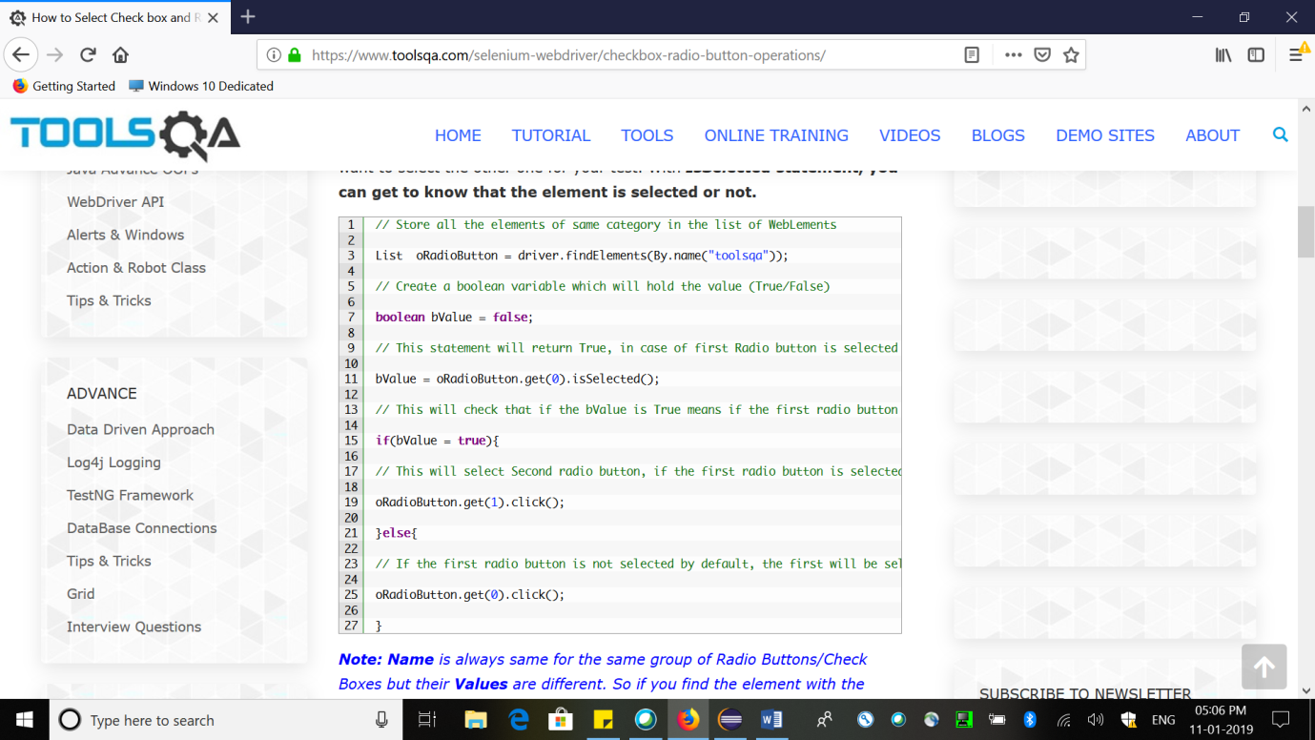

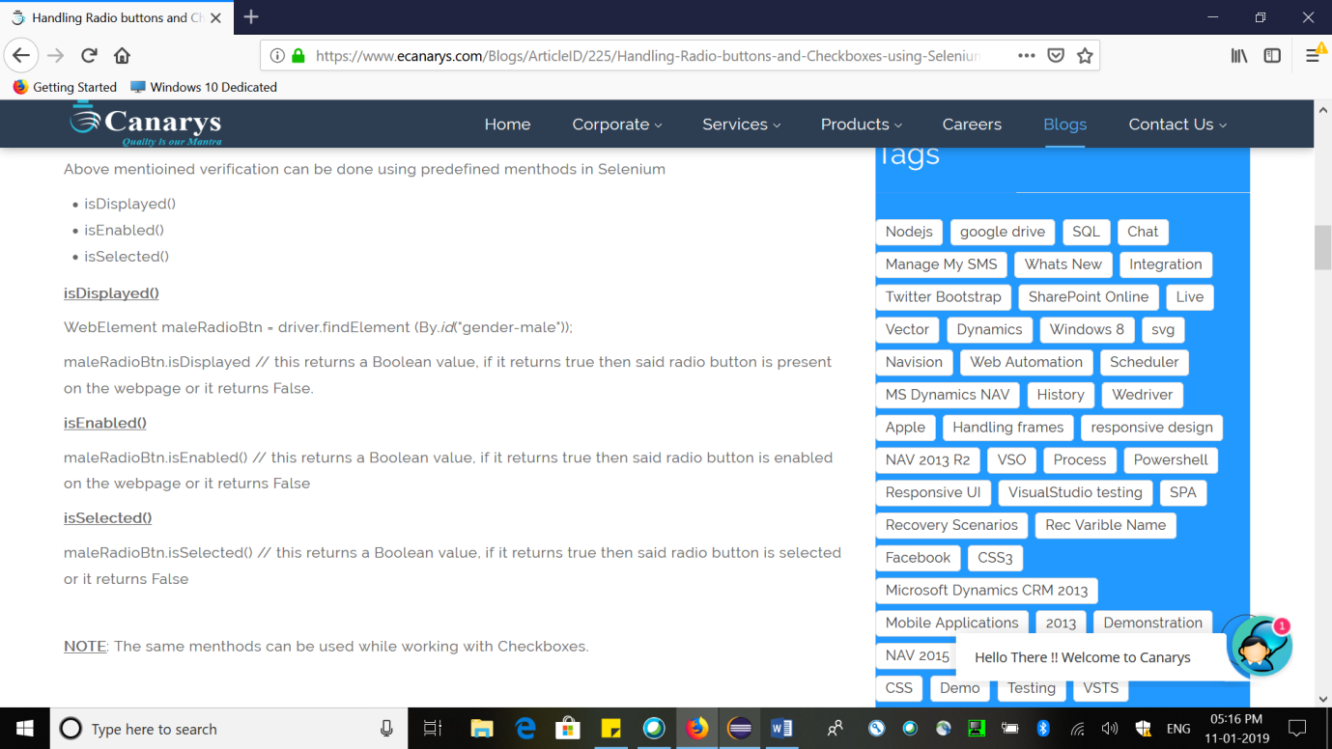

Gecko Driver:

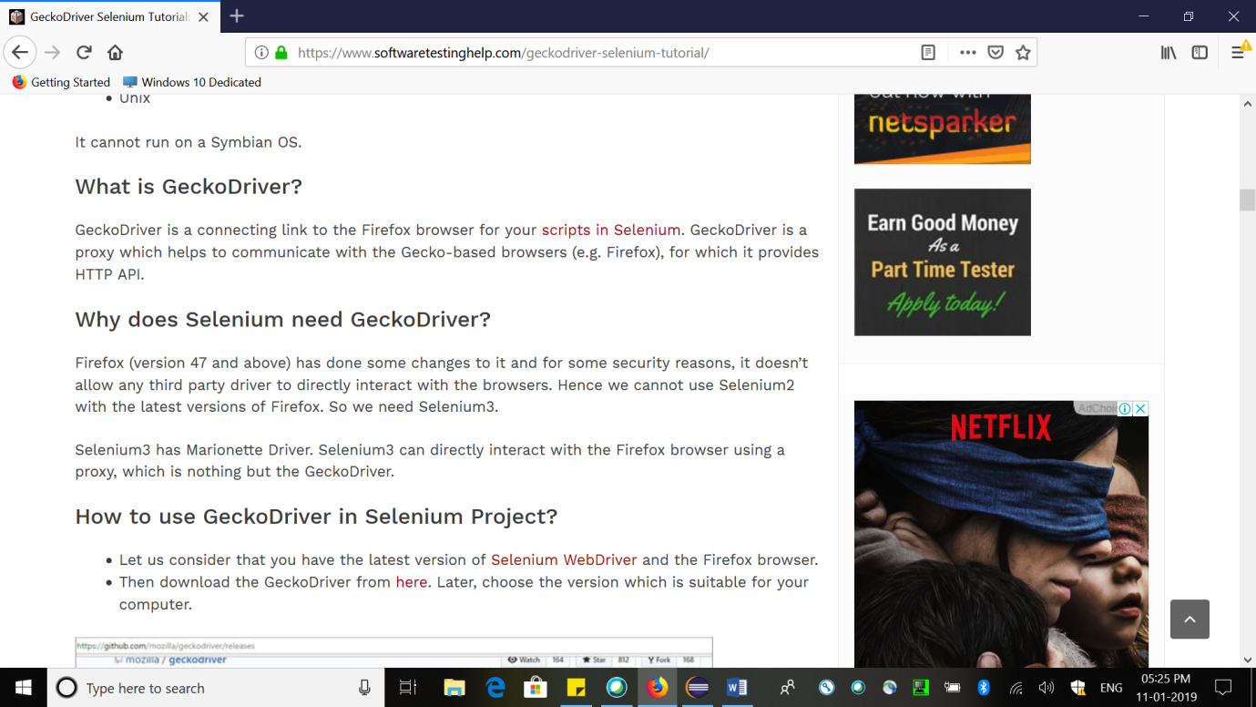

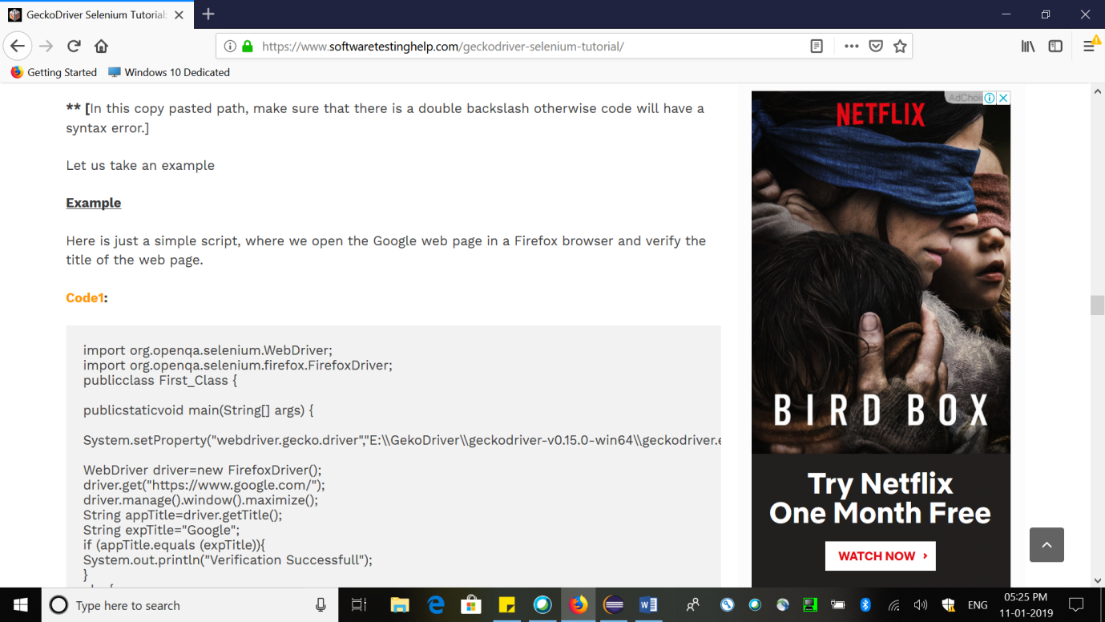

Difference Between GetText and GetAttribute

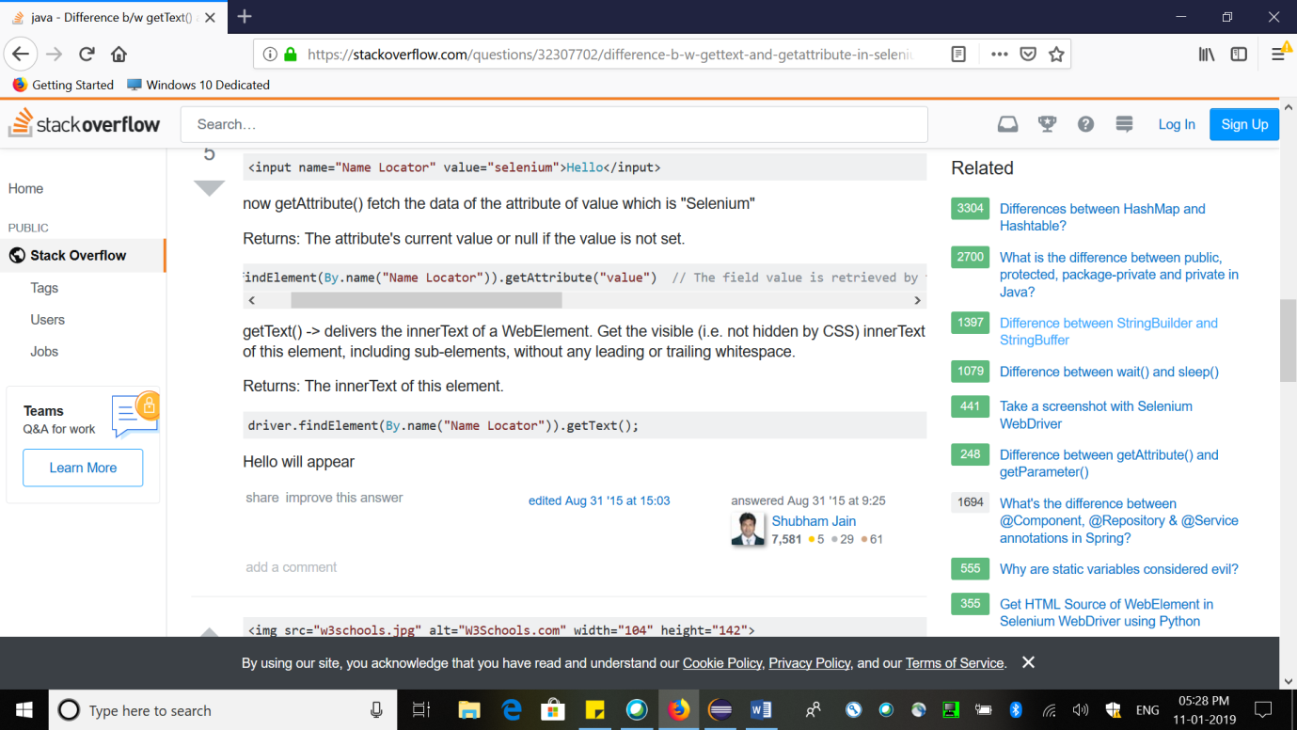

Sending Key operations:

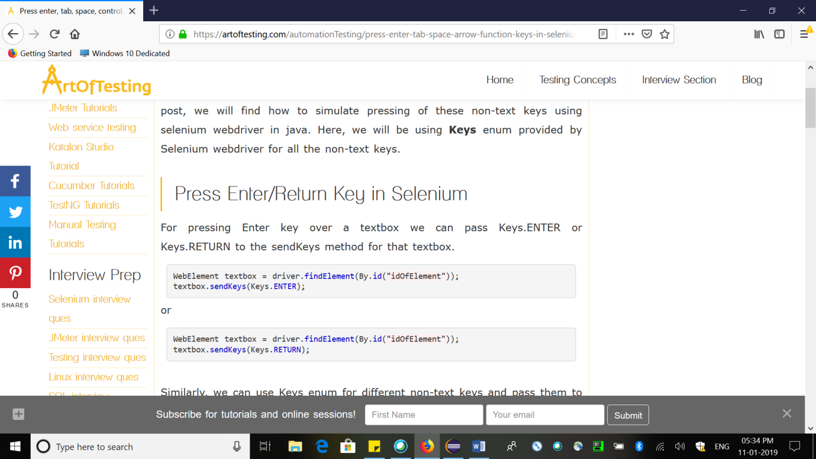

sendKey always takes string values.

Int to string:

String.ValueOf(int)

StringToInt:

Integer.parseInt(Str)

Implicit Wait:

The implicit wait will tell to the web driver to wait for certain amount of time before it throws a **"No Such Element Exception".** The default setting is 0. Once we set the time, web driver will wait for that time before throwing an exception.

driver.manage().timeouts().implicitlyWait(TimeOut, TimeUnit.SECONDS);

Explicit Wait

The explicit wait is used to tell the Web Driver to wait for certain conditions (**Expected Conditions**) or the maximum time exceeded before throwing an "**ElementNotVisibleException**" exception.

WebDriverWait wait=new WebDriverWait(driver, 20);

WebElement guru99seleniumlink;

guru99seleniumlink = wait.until(ExpectedConditions.visibilityOfElementLocated(By.xpath("/html/body/div[1]/section/div[2]/div/div[1]/div/div[1]/div/div/div/div[2]/div[2]/div/div/div/div/div[1]/div/div/a/i")));

guru99seleniumlink.click();

The following are the Expected Conditions that can be used in Explicit Wait

1. alertIsPresent()
2. elementSelectionStateToBe()
3. elementToBeClickable()
4. elementToBeSelected()
5. frameToBeAvaliableAndSwitchToIt()
6. invisibilityOfTheElementLocated()
7. invisibilityOfElementWithText()
8. presenceOfAllElementsLocatedBy()
9. presenceOfElementLocated()
10. textToBePresentInElement()
11. textToBePresentInElementLocated()
12. textToBePresentInElementValue()
13. titleIs()
14. titleContains()
15. visibilityOf()
16. visibilityOfAllElements()
17. visibilityOfAllElementsLocatedBy()
18. visibilityOfElementLocated()

FluentWait:

The fluent wait is used to tell the web driver to wait for a condition, as well as the **frequency** with which we want to check the condition before throwing an "ElementNotVisibleException" exception.

Wait<WebDriver> wait = new FluentWait<WebDriver>(driver)

.withTimeout(30, TimeUnit.SECONDS)

.pollingEvery(5, TimeUnit.SECONDS)

.ignoring(NoSuchElementException.class);

Alert

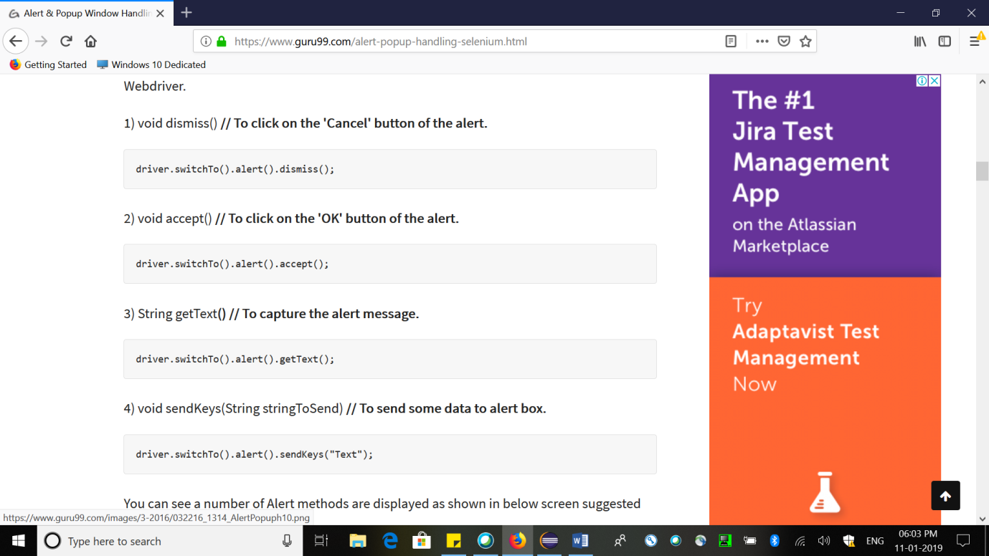

Alert alert = driver.switchTo().alert();

FRAME

iFrame: This Frame option

We can even identify total number of iframes by using below snippet.

Int size = driver.findElements(By.tagName("iframe")).size();

driver.switchTo().frame(0);

driver.switchTo().frame("a077aa5e"); - name/id

driver.switchTo().defaultContent();

Window Handling

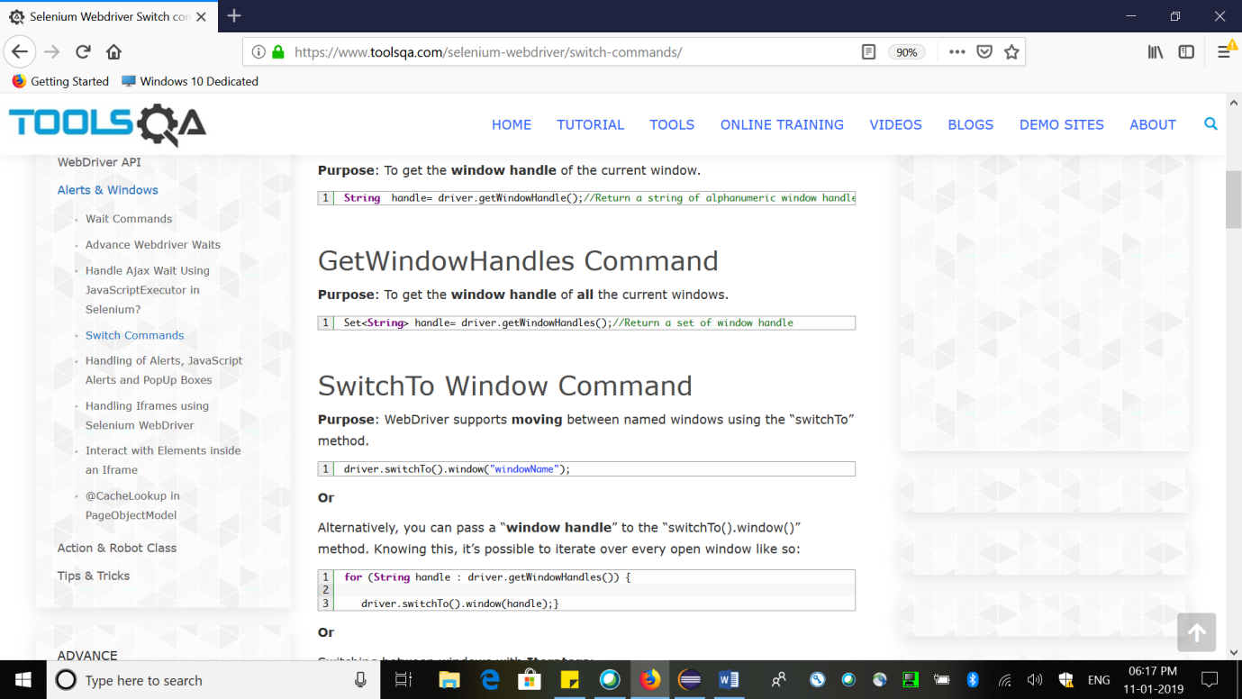s

Robot Class

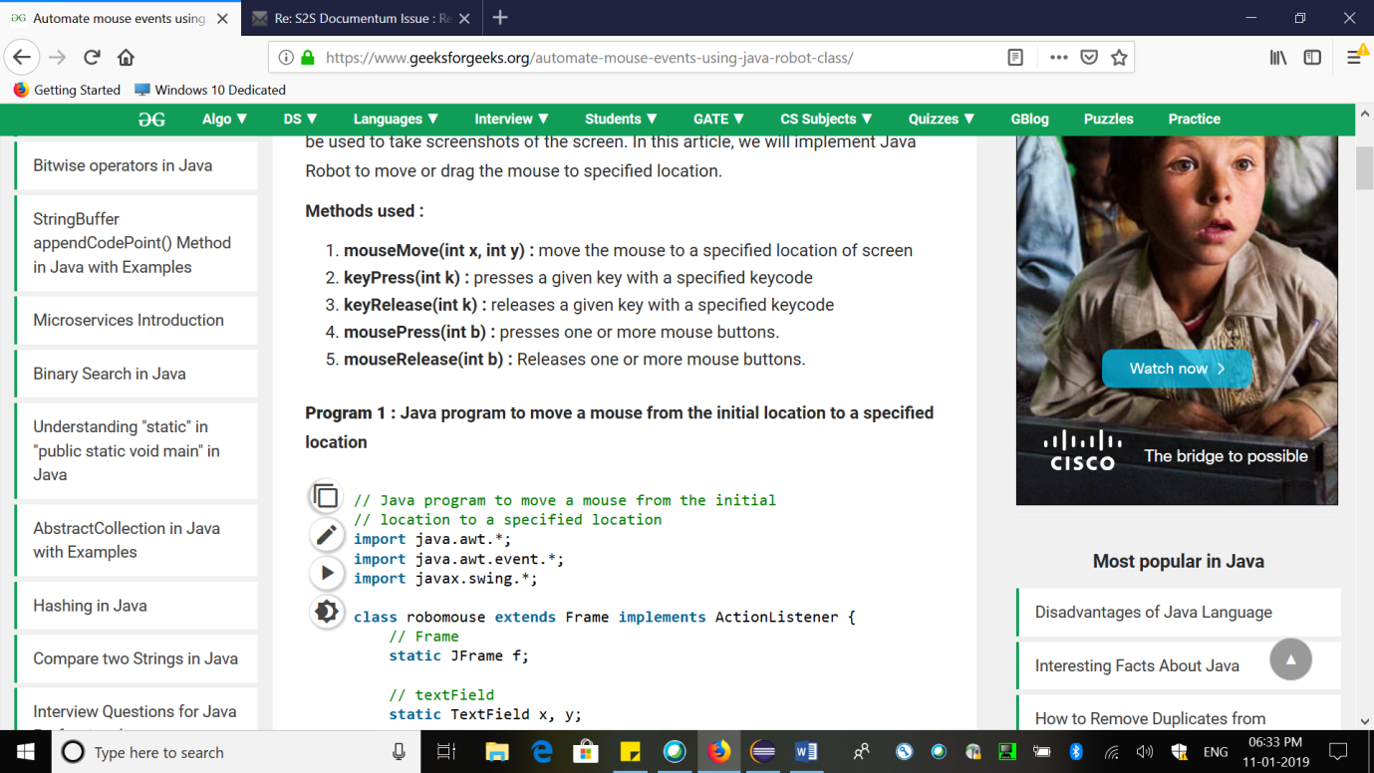

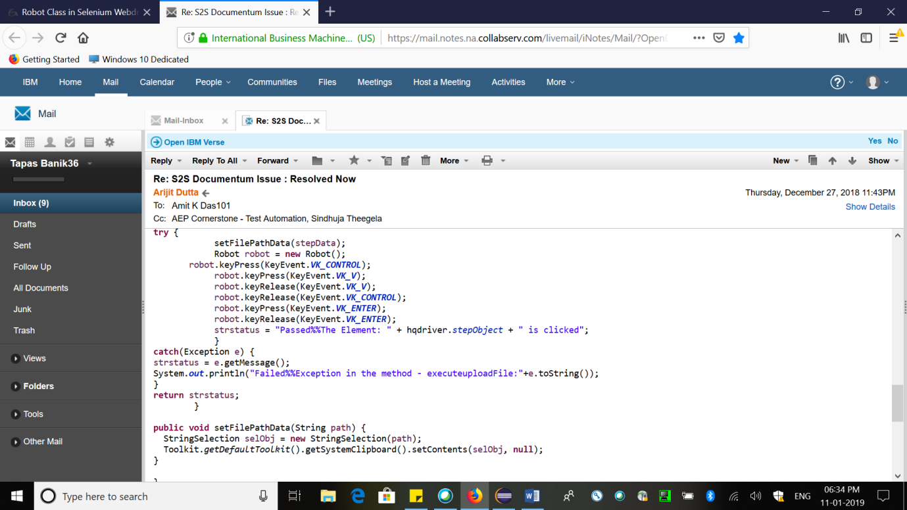

Left Click

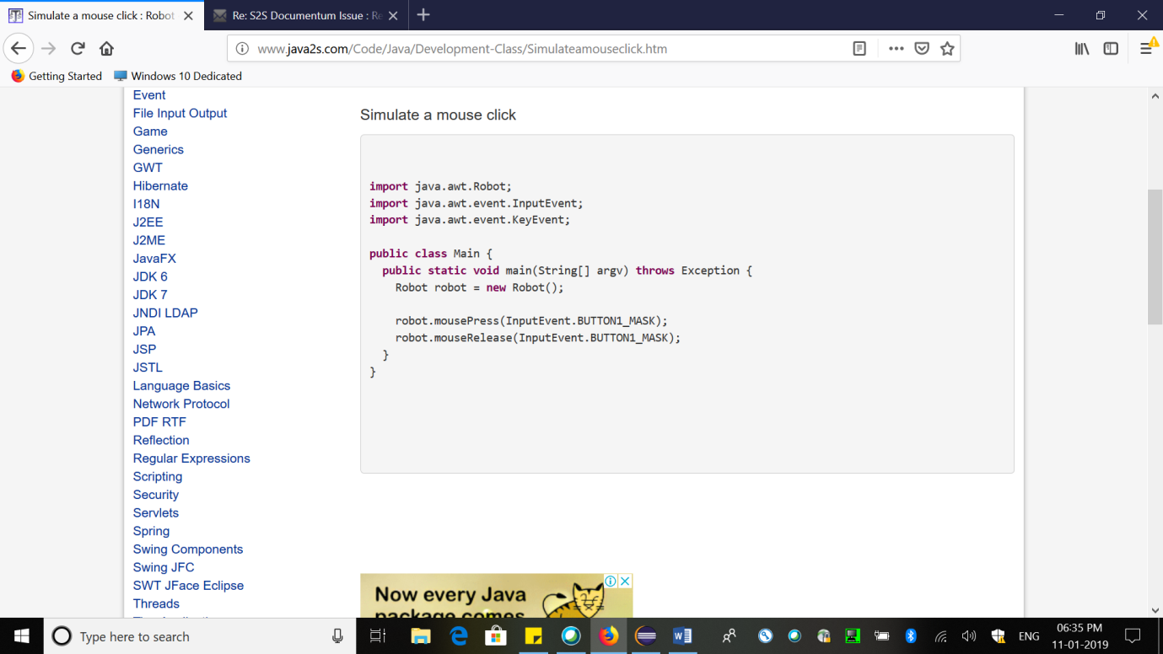

Right Click

Button3_MASK

// Scroll MouseWheel

robot.mouseWheel(5);

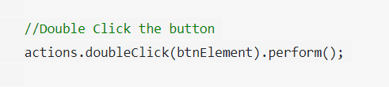

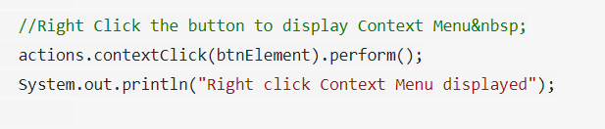

Static HTML Table:

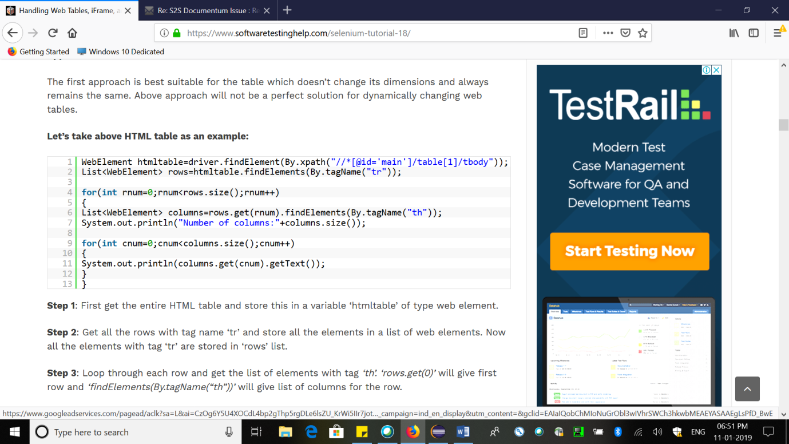

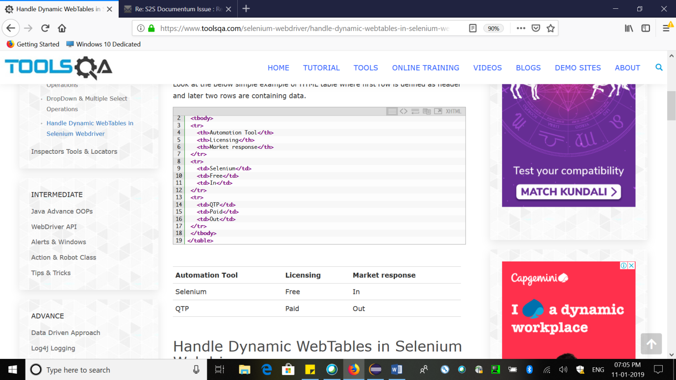

Dynamic Elements:

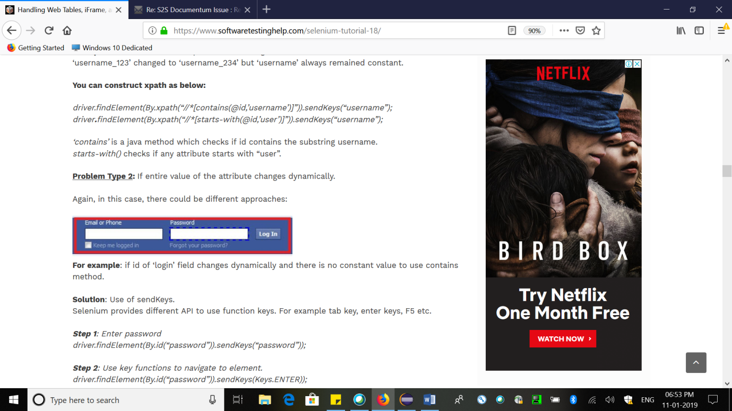

Dynamic Table:

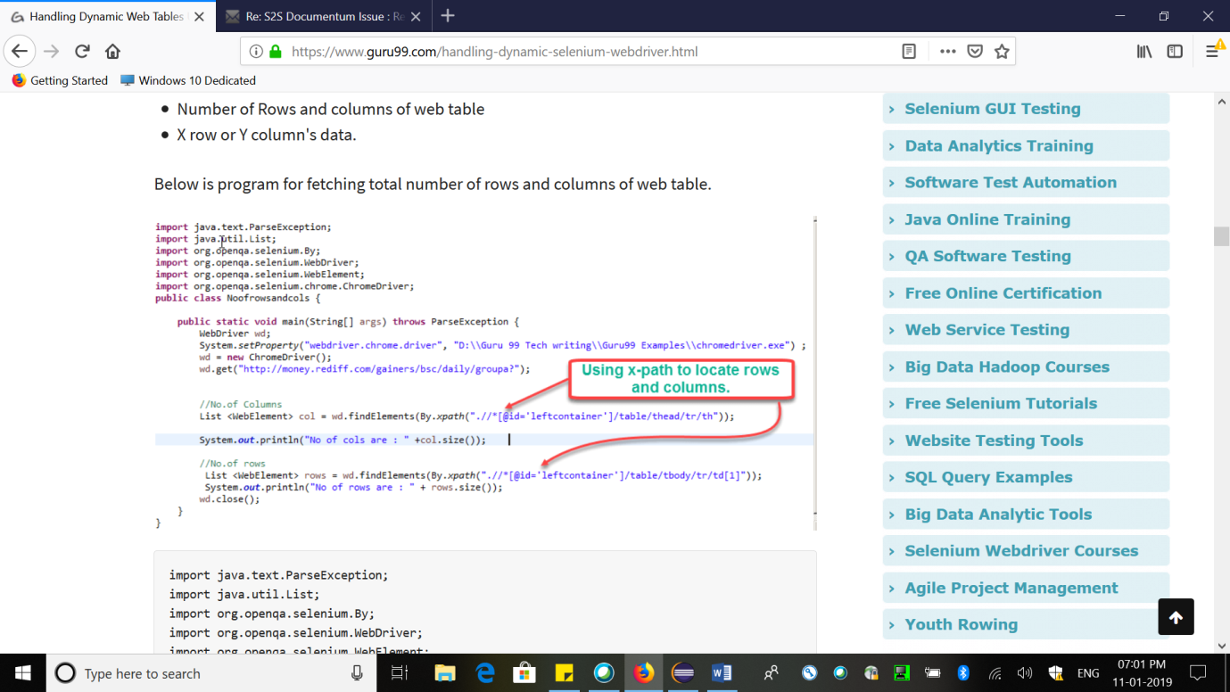

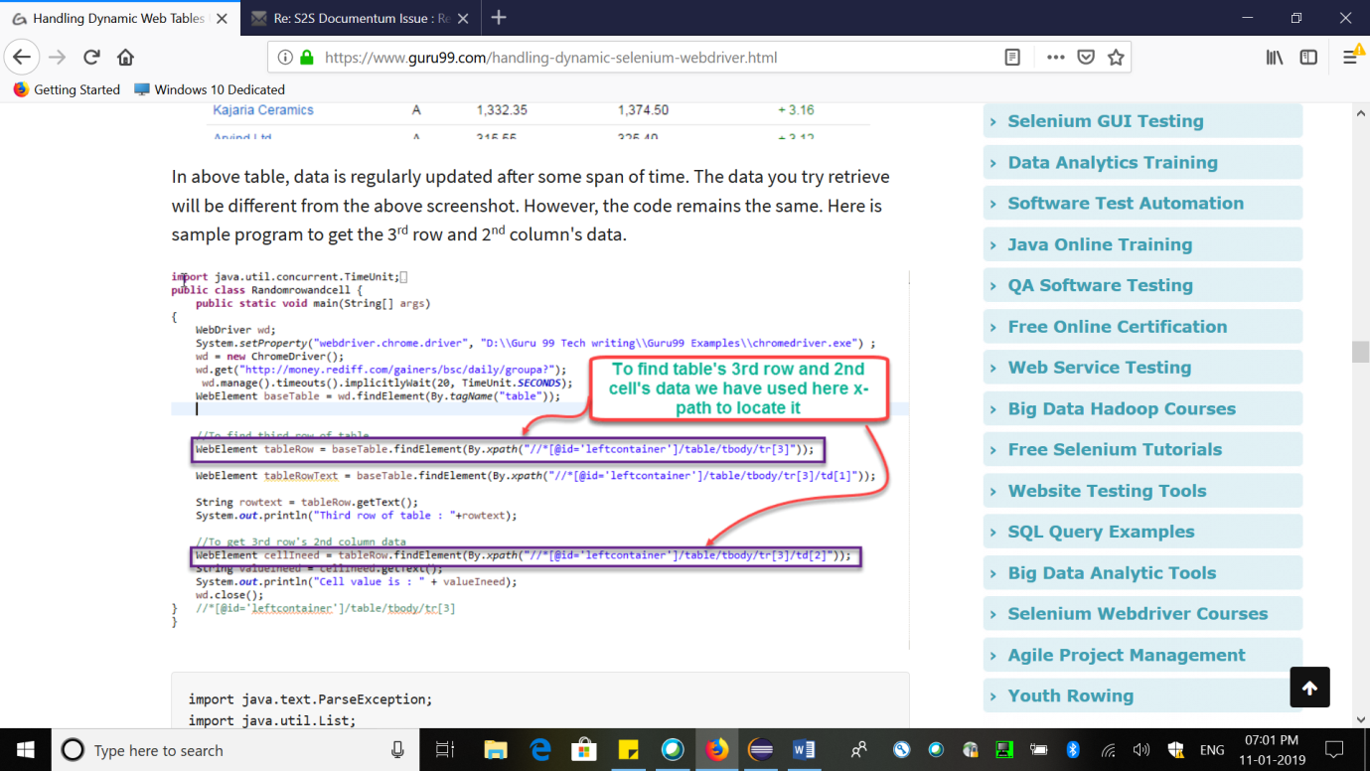

Split Method:

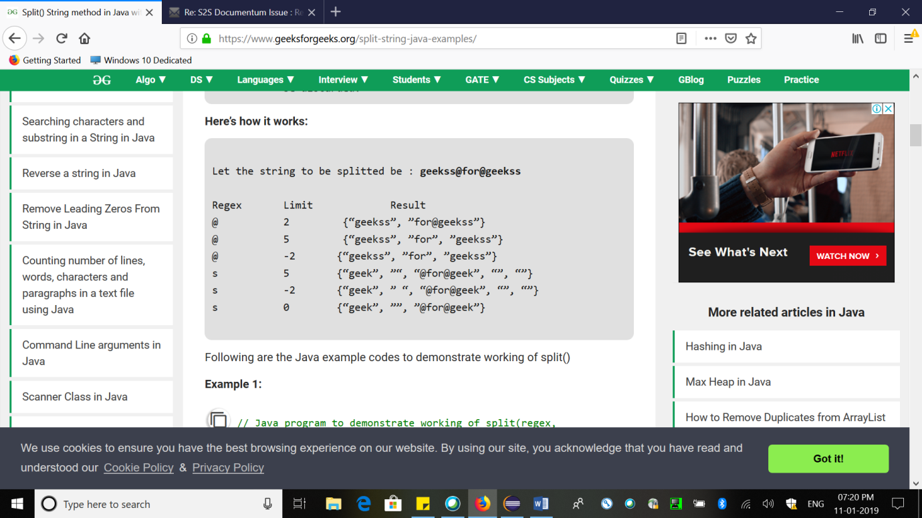

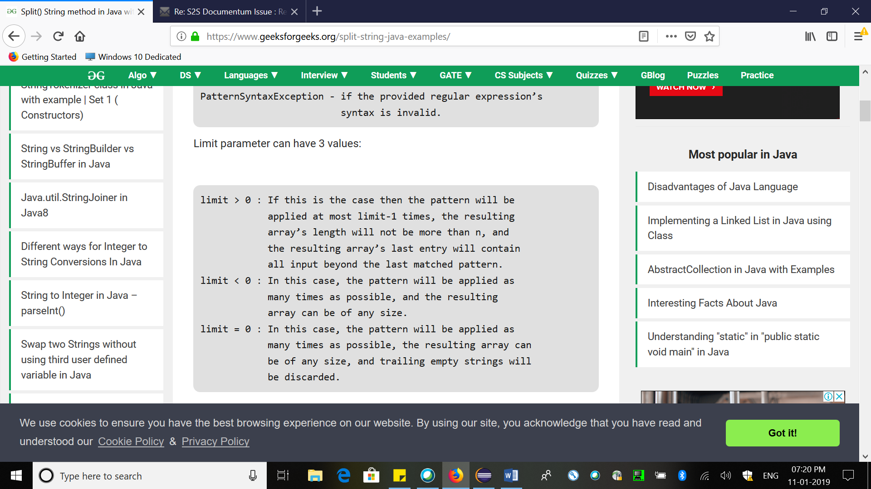

String to Character in Java

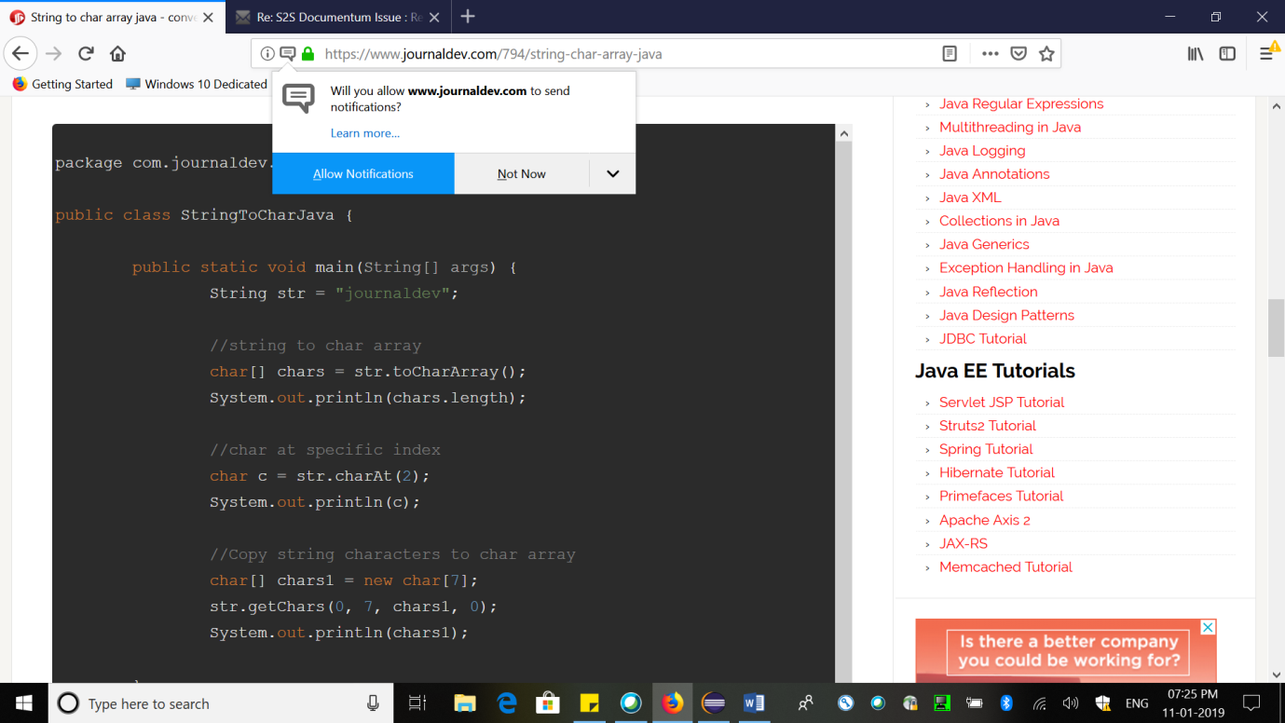

REST GET

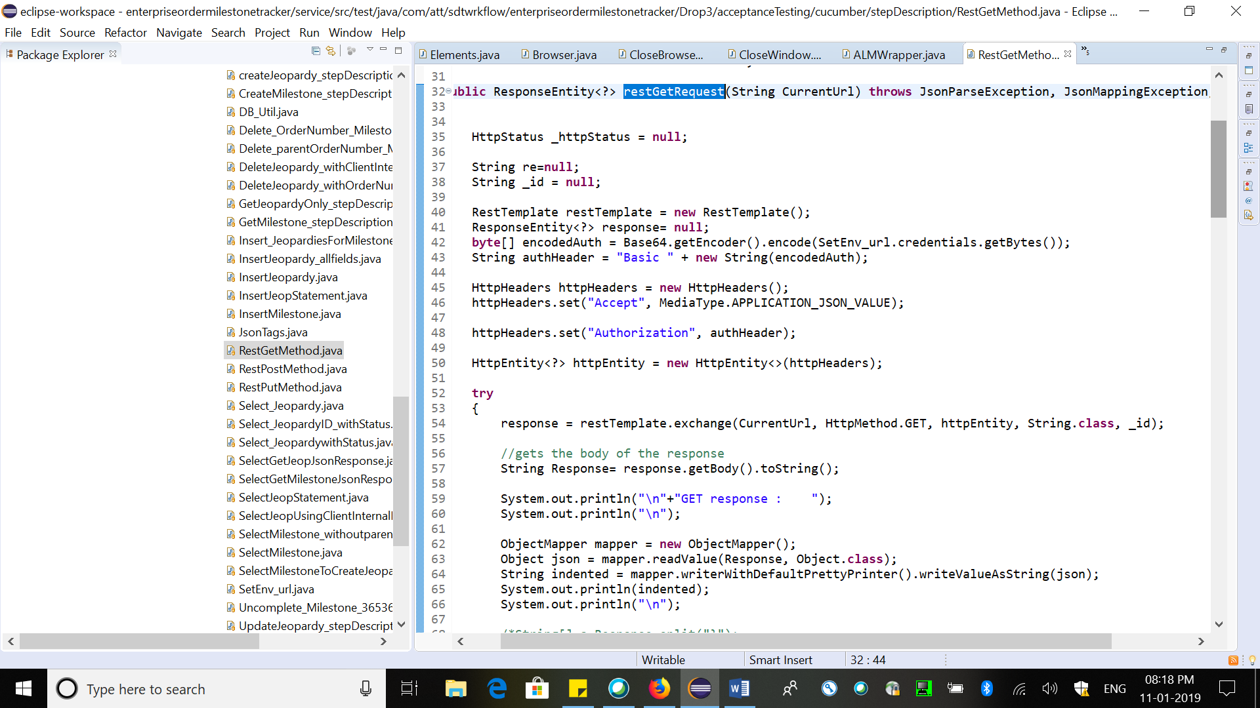

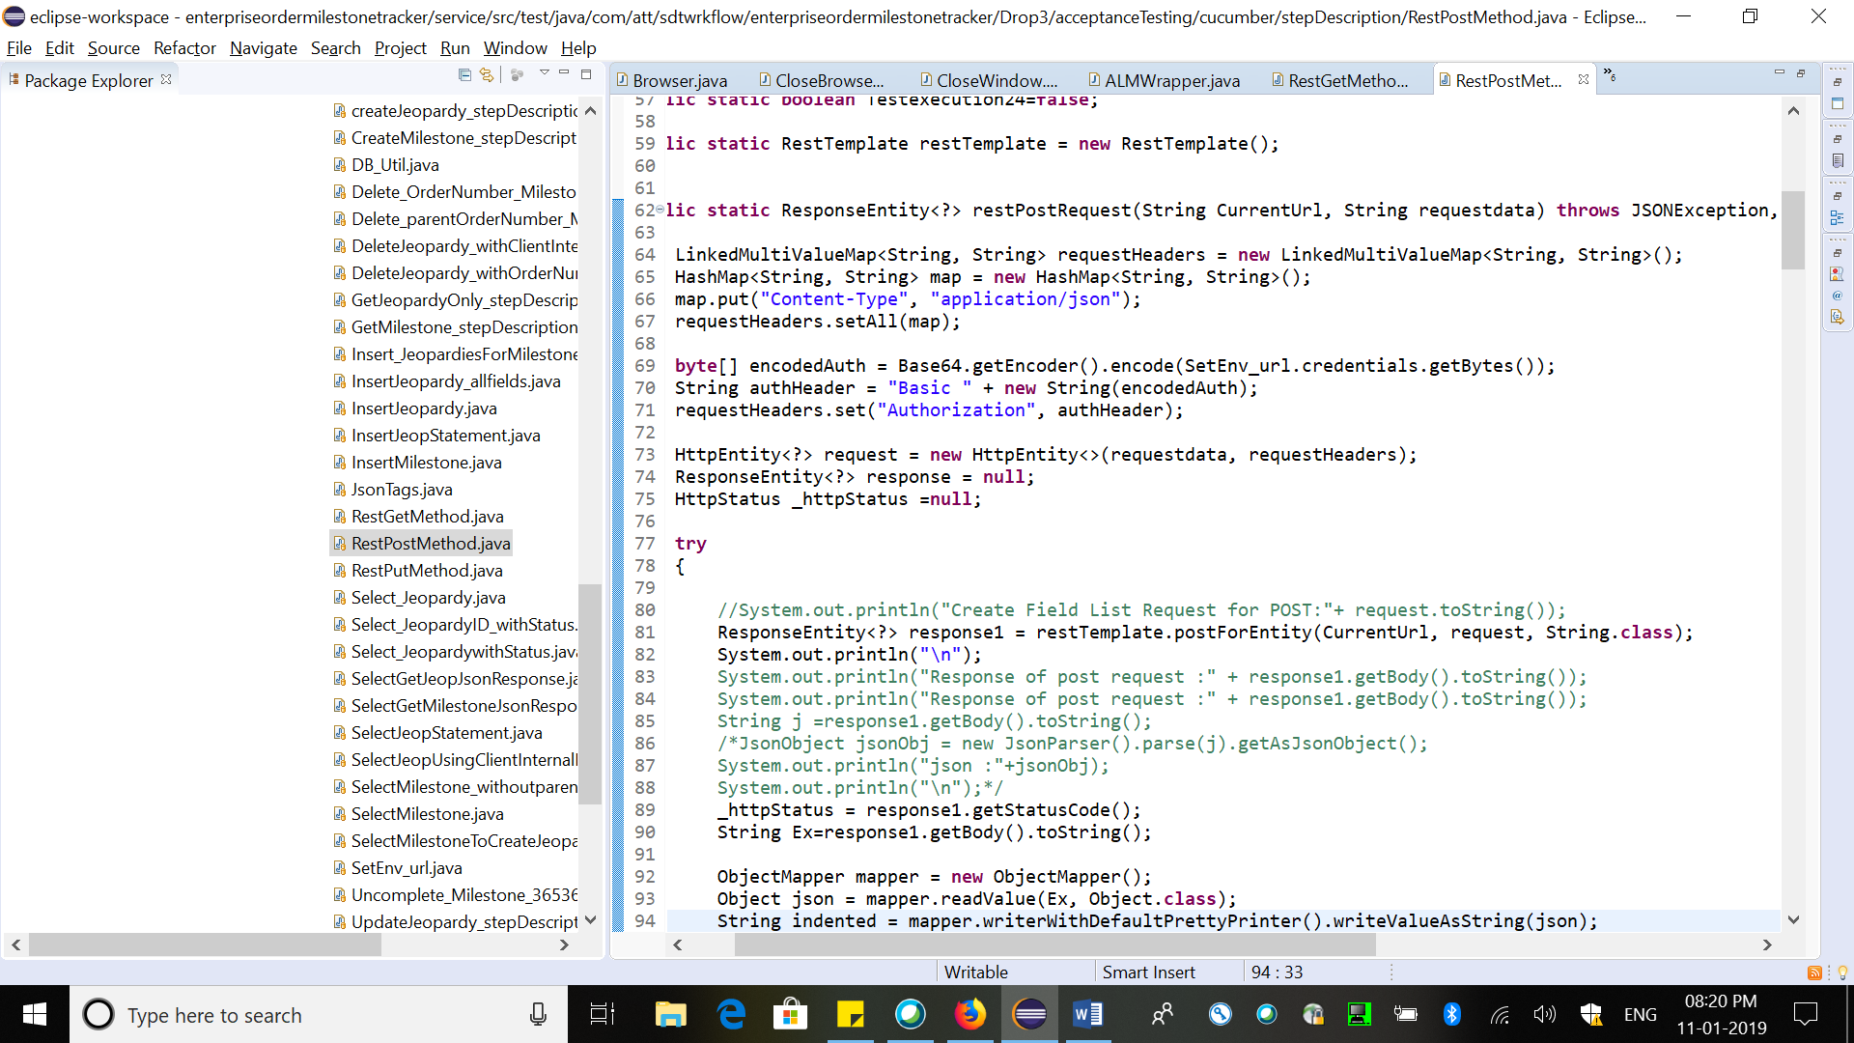

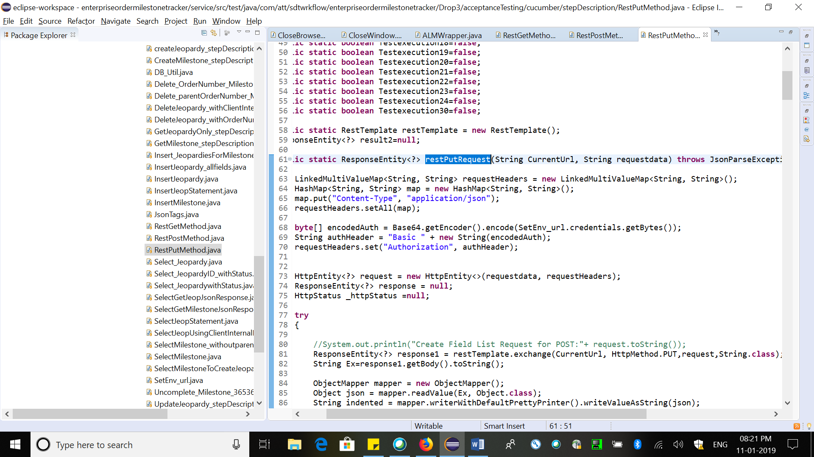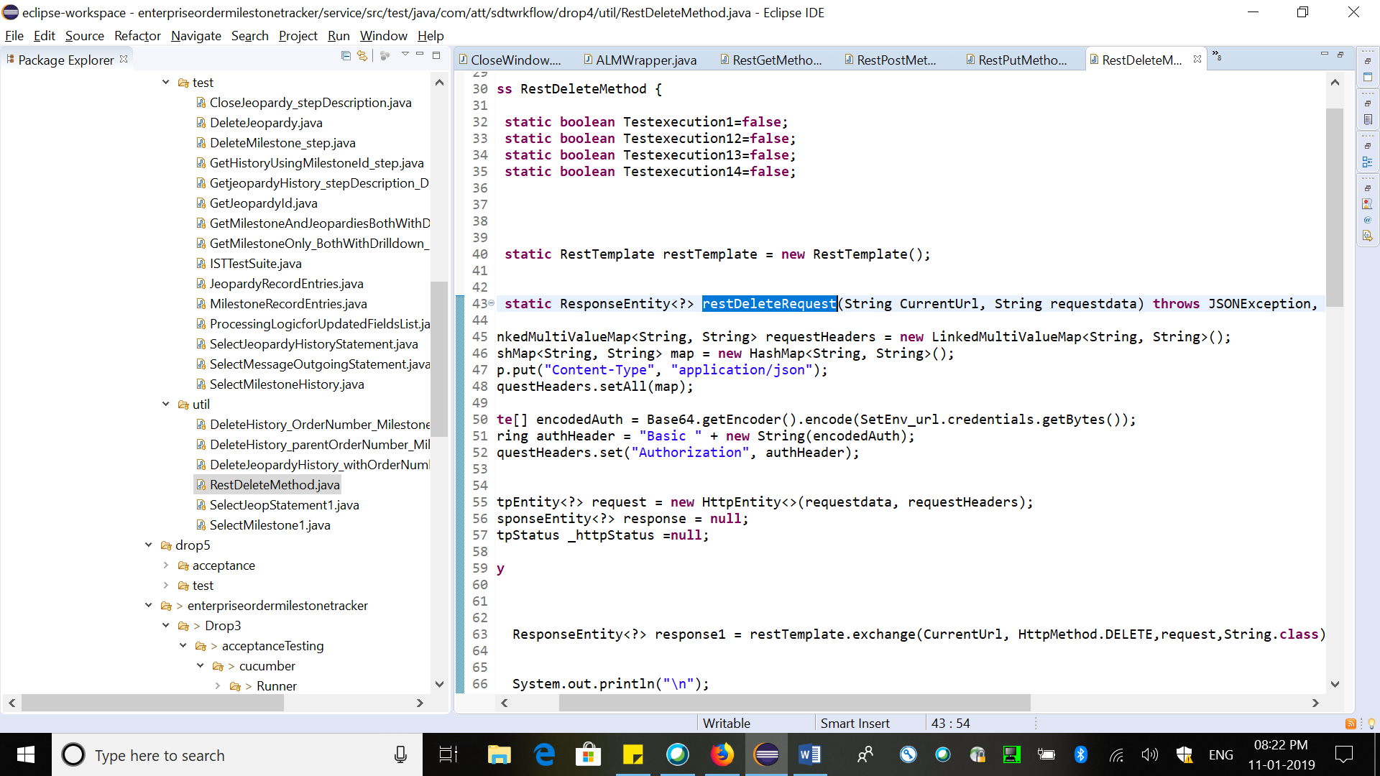

GET response:

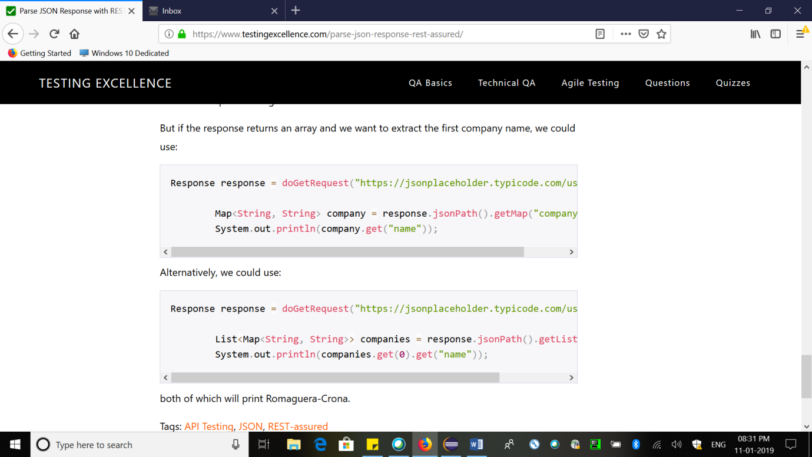

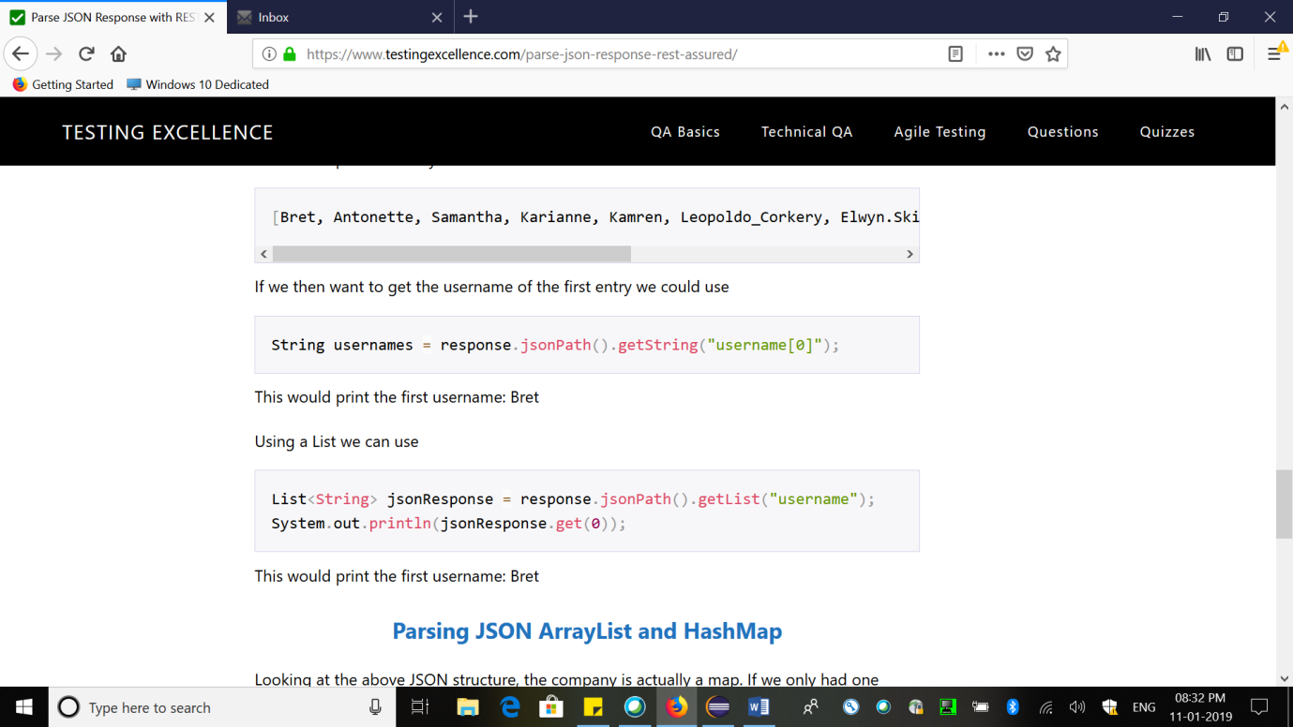

DB Calling

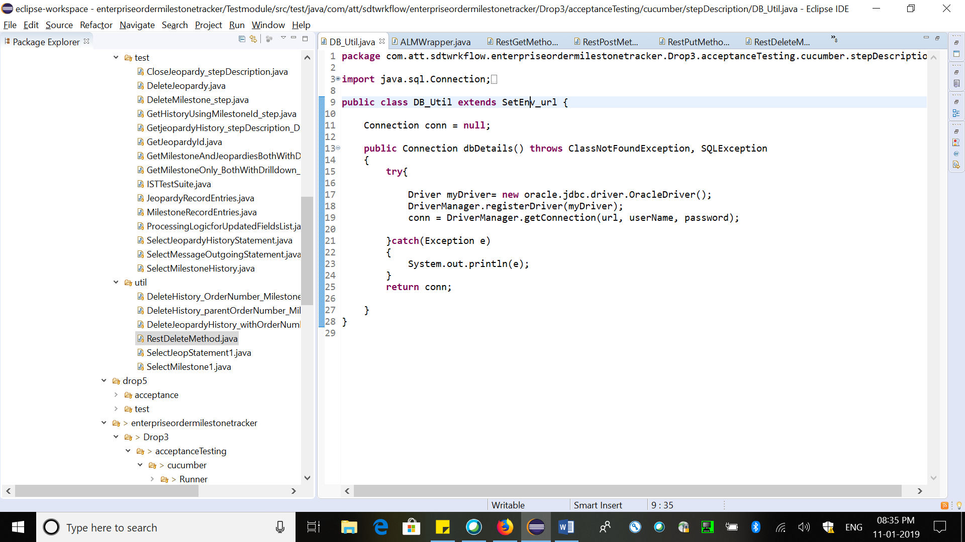

**TestNG**

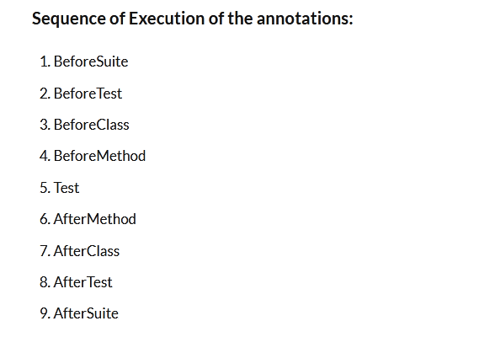

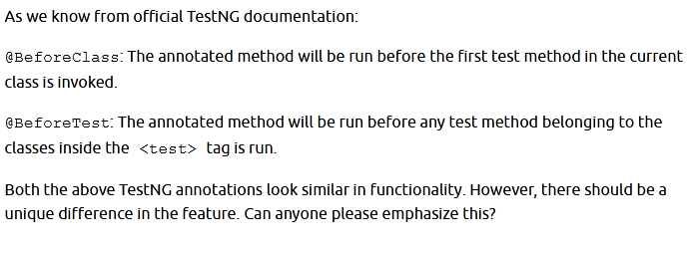

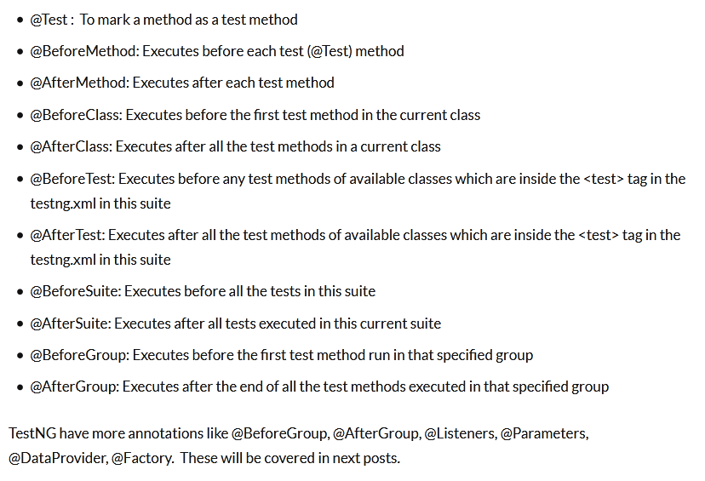

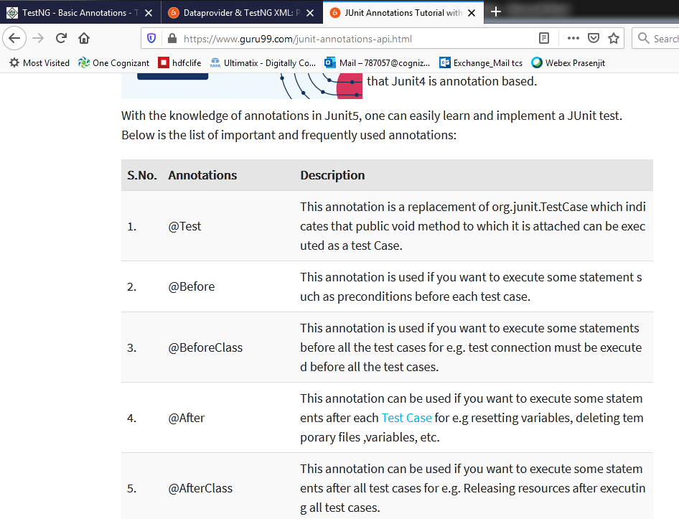

Before in junit=beforeMethod in TestNG

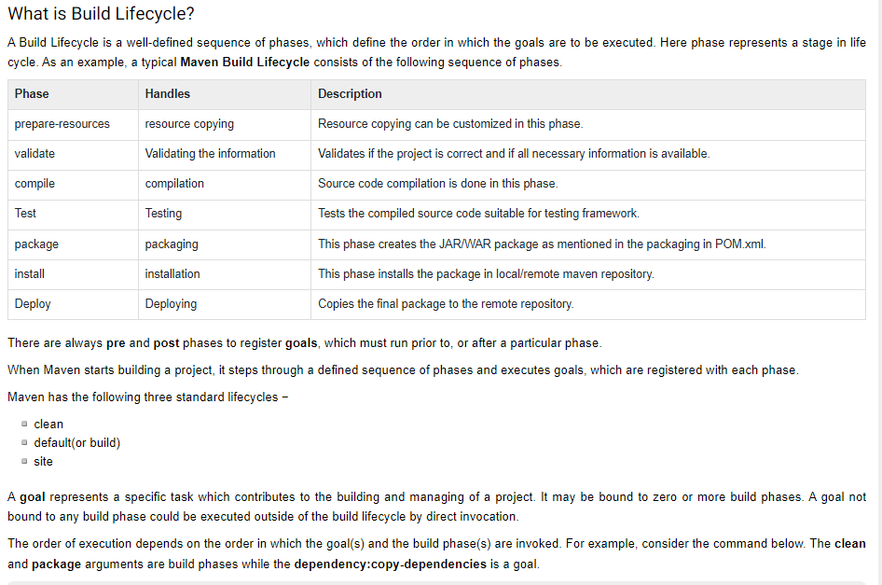

**Scrolling in Selenium**

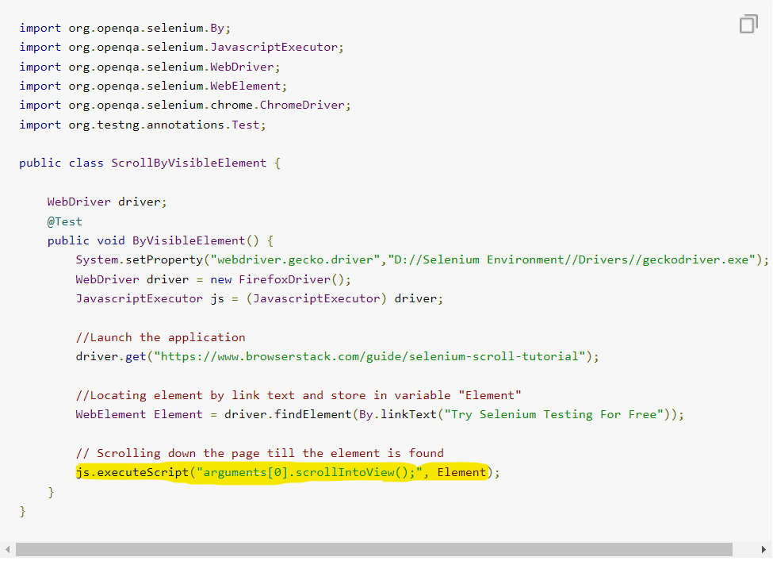

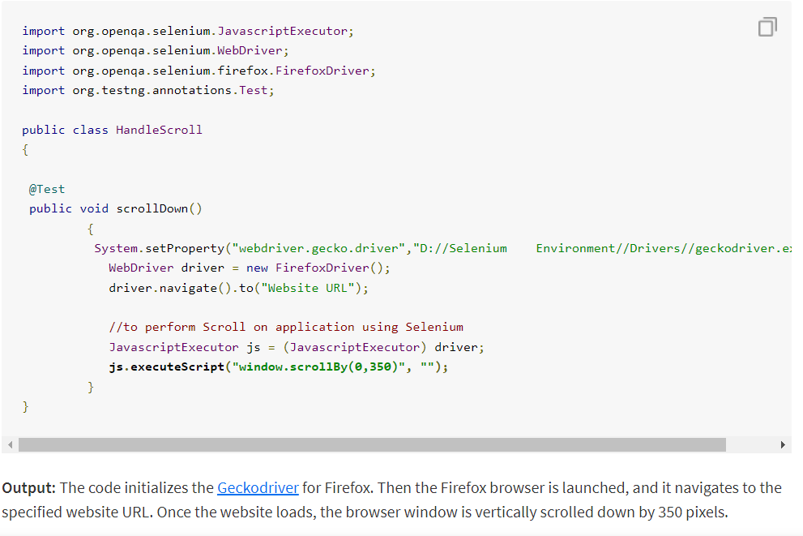

**Take Screenshot**

package BrowserstackScreenShot;

import java.io.File;

import org.apache.commons.io.FileUtils;

import org.openqa.selenium.OutputType;

import org.openqa.selenium.TakesScreenshot;

import org.openqa.selenium.WebDriver;

import org.openqa.selenium.firefox.FirefoxDriver;

import org.testng.annotations.Test;

public class BStackTakeScreenshot {

@Test

public void testBStackTakeScreenShot() throws Exception{

WebDriver driver ;

System.setProperty("webdriver.firefox.marionette","c:\\geckodriver.exe");

driver = new FirefoxDriver();

//goto url

driver.get("https://www.browserstack.com");

//Call take screenshot function

this.takeSnapShot(driver, "c://test.png") ;

}

/**

* This function will take screenshot

* @param webdriver

* @param fileWithPath

* @throws Exception

*/

public static void takeSnapShot(WebDriver webdriver,String fileWithPath) throws Exception{

//Convert web driver object to TakeScreenshot

TakesScreenshot scrShot =((TakesScreenshot)webdriver);

//Call getScreenshotAs method to create image file

File SrcFile=scrShot.getScreenshotAs(OutputType.FILE);

//Move image file to new destination

File DestFile=new File(fileWithPath);

//Copy file at destination

FileUtils.copyFile(SrcFile, DestFile);

}

}

**Drag & Drop:**

Actions action = new Actions(driver);

action.dragAndDrop(Sourcelocator, Destinationlocator).build().perform();